Project Report on

**“Develop and Deploy an Application for Nutrition Assistant”** submitted in the fulfillment of the requirement of the **IBM Hack**

# Challenge 2022 by Students of Biyani Girls College



**Team Name :-** HealthyBiyanite

**App Name :-** HealthCareApp

# Team Members :- Team Mentor :-

Ms. Sakshi Sharma (Team Leader) Ms. Sanjana Purohit

Ms. Rashi Sharma Assistant Professor(IT)

Ms. Juhi Vijayvargiya

Ms. Priti Tanwar

# CONTENT

* **INTRODUCTION**
* **LITERATURE SURVEY**
* **THEORITICAL ANALYSIS**
* **EXPERIMENTAL INVESTIGATIONS**
* **FLOWCHART**
* **RESULTS**
* **ADVANTAGES & DISADVANTAGES**
* **APPLICATIONS**
* **CONCLUSION**
* **FUTURE SCOPE**
* **BIBILOGRAPHY**
* **APPENDIX**

# INTRODUCTION

In today's lifestyle, people are moving towards achieving a fit and healthy body. This shift has changed the way people are living right now in almost every household. Hence, healthy eating and nutritious food have become an essential part of everyone’s lifestyle to achieve a balanced and healthy life in such busy and hectic environment. On the other hand, an imbalanced diet can lead to disastrous results on one’s health, which may lead to diseases such as obesity, diabetes, etc. However, such conventional diseases and their symptoms can be reduced or prevented by active living and by including better nutritional diet. Hence, those in search of healthy and nutritious food have used the internet to research the food’s nutrition values. In the Android market, there are many healthcare applications available that provide diet plans for their clients. However, there is no such app available that can provide a diet plan as well as some additional features to their user. Hence, to make their fitness path a bit smoother and to enhance their experience, we have built an Android application, to provide a broader approach in providing a healthier living through nutritious diet plan, dietitians, nutritious values of the food, reminder features and etc. to the users. Food recognition systems is a system which could identify the type of food in an image that is captured with a camera. This is an idea to help the users to keep track of their calorie intake. The user can automatically record their food and calorie intake with just a snap of its photo.

# LITERATURE SURVEY

## Existing Problems :-

**[1].** **Issues in dietary intake assessment of children and adolescents:** There has been a number of proposed methods for measuring daily food diet information. In this, one existing system which asks the user to give the details of food and drinks he/she had consumed in 24 hours to the instructor or dietitian but the problem with this type of method is sometimes people won’t be able to remember exactly what they ate with content and amount. It is hard for the user to explain and give details of everything he/she consumed in the last 24- hours.

**[2].** **Health aware:** Tackling obesity with health aware smart phone systems, yet another approach where user can take a picture of the food from a smartphone and its compared with the predefined similar picture with it is known nutrition value stored in the database. The main disadvantage of this system is that it does not consider the size of the food, which is extremely important.

## Proposed Solution :-

In this project we have created an application that aims to provide a better health to users. This app aims to identify the food nutrients like vitamins, carbs, etc. in the food by classifying the food image. Our method employs Clarifai's AI-Driven Food Detection Model for accurate food identification and Food API's to give the nutritional value of the identified food.

**THEORITICAL ANALYSIS**

## Hardware & Software Designing:-

### Software Requirements:-

Android Studio, Firebase Data Connectivity, Machine Learning

(TensorFlowLite Model)

**Hardware Requirements:-**

Intel Corei3 processor, 8GB Ram (for smooth processing)

# EXPERIMENTAL INVESTIGATIONS

Experimental investigations conducted so far on simple perspex and mortar models clearly indicate that the method of virtual work is quite adequate to predict the [elastic deflections](https://www.sciencedirect.com/topics/engineering/elastic-deflection) of the flag structures. The structural systems described above appear to hold promising prospects in view of the great strength of slabs in their own planes. Further, it appears possible that, by judiciously stacking and interlocking a number of the basic assemblies, multistorey buildings can be conceived combining the distinct advantages of clear spans at certain floor levels and structural efficiency.

In case of our project, experimental investigations are totally based upon surveying other food and health related apps available in the market. Also include those features which are not included in these apps. So that we can represent all the possible features through our app with food recognition and nutrients extraction

facility.

# FLOW CHART

A flowchart is a type of diagram that represents a workflow or process. A flowchart can also be defined as a diagrammatic representation of an algorithm, a step-by-step approach to solving a task.

The flowchart shows the steps as boxes of various kinds, and their order by connecting the boxes with arrows. This diagrammatic representation illustrates a solution model to a given problem. Flowcharts are used in analysing, designing, documenting or managing a process or program in various fields.

A flow chart is a graphical or symbolic representation of a process. Each step in the process is represented by a different symbol and contains a short description of the process step. The flow chart symbols are linked together with arrows showing the process flow direction.

**Flow Chart for Solution:**

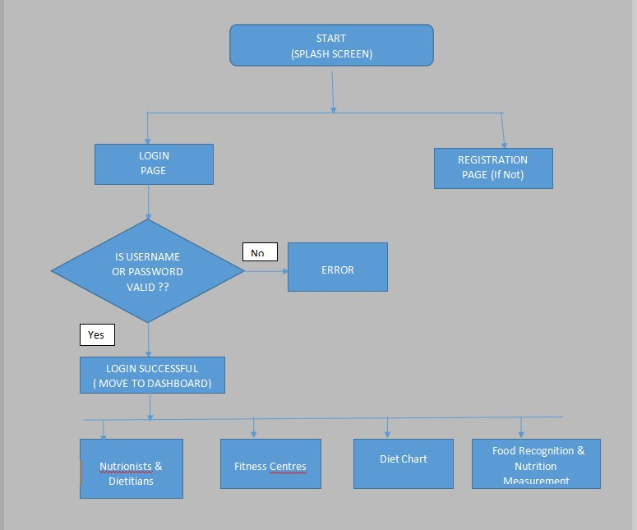

# RESULTS

## Screenshots :-

### Home Page :- Registration Page :-

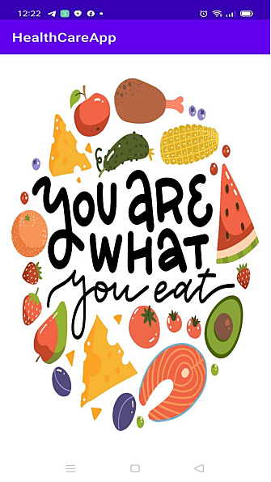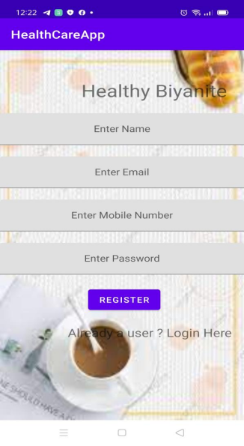

### Login Page :- Main Dashboard :-

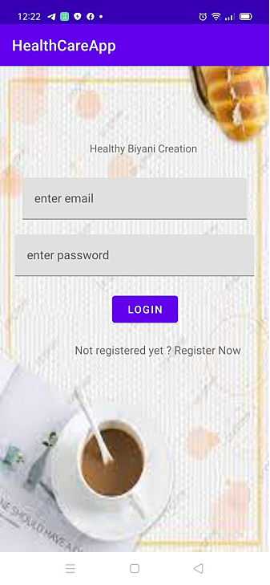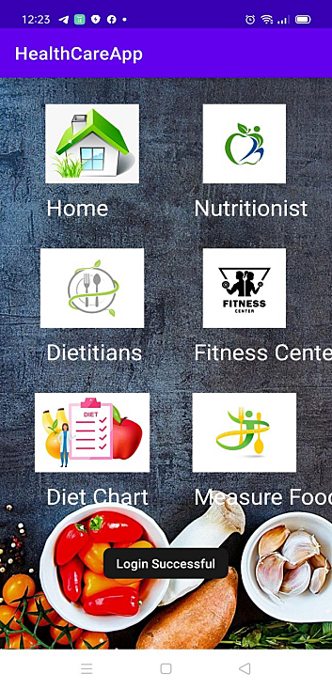

### Food Recognition and Nutrients Extraction Page :-

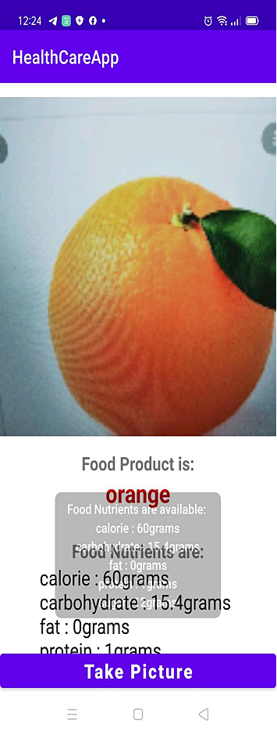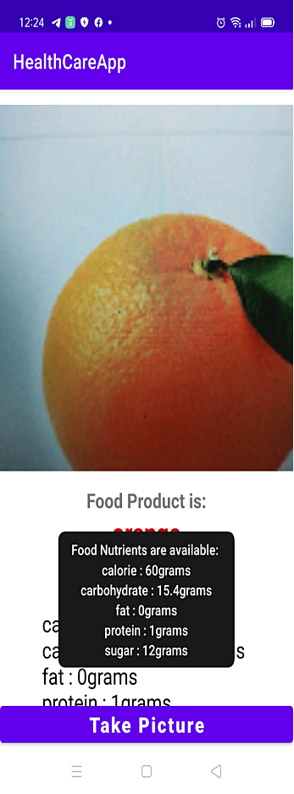

# ADVANTAGES & DISADVANTAGES

## Some of the advantages are :-

1. **They can help you eat healthier:** Perhaps most importantly, they can help you improve your diet so you are eating healthier. Using a nutrition app will inherently help you eat a better and more optimized diet. Not only do these apps typically have calorie counters in them, but they can show you how many macro and micronutrients you are getting into your diet. Without having an app that tracks your food intake, you’re going to find it increasingly difficult to track this manually. These apps will generally make recommendations on what foods you should be looking to get into your diet. You cannot fool yourself when you are using a nutrition app. You will see the foods you are eating and the app will generally tell you if you are consuming too much of any type of food.

1. **Track your progress:-** One of the most important things that you can do when you are looking to improve your diet choices and your weight loss efforts is to track your progress. This is something that you will either need to do manually or in an automated fashion using an app like this. A nutrition app that can track and monitor your progress is worth using. Without progression tracking, you are going at things without a measuring stick. Having an app that tracks and monitors your progress is the only way to identify what you are doing right and what you are doing wrong. It also shows you what you may need to change to improve. Being able to check your progress at a glance can do wonders for your efforts. Not only will you have something providing you with additional motivation, but it can also put things into perspective when you aren’t necessarily visualizing any results from your efforts.

1. **It allows you to analyze your own food choices to assess and tweak yours eating plan and patterns:-** Do you eat a bulk of your calories after 6pm? Are you eating 350 calorie snacks? Did you forget to drink water yesterday? When you insert the foods, beverages and quantities you are eating, it gives you a “big picture” that allows you to quickly assess your diet and food behaviors. Most individuals don’t need a healthcare professional to point out that there is no breakfast 4 out of 7 days a week OR that they aren’t eating fish for omega-3 fatty acids OR that they didn’t get a veggie at dinner- you can assess on your own when it is right in front of you. You can analyze your choices and slowly make realistic tweaks to your eating patterns to improve your health.

## Some of the disadvantages are:-

1. **It can actually remove a level of mindfulness because the goal is to hit target numbers NOT listen to your body:** What if you are hungrier one day? We might be compelled to restrict if we don’t have any calories left to consume per the tracker recommendations. What if you have calories left but you are not really hungry? This gives you permission to eat when your body isn’t requiring energy.

1. **It’s not sustainable long term:** Nobody can commit to tracking all of their meals over a lifetime. That is simply unrealistic. Therefore, this tool is not a sustainable long term habit and may promote a “diet mentality,” an approach that can be turned on/off depending on whether we are being ‘good’ or ‘bad.’ A healthy lifestyle includes healthy boundaries with foods and the ability to say ‘no’ and the ability to enjoy treats. We don’t turn on/off a healthy lifestyle- it’s just how we live.

1. **Inaccuracy:** One of the downsides to using an app for calorie counting is the fact that it’s not always going to be accurate. Whether you mistype something or it tracks incorrectly, it can completely throw off your true macronutrient count. If you aren’t logging things accurately, you could be hurting yourself more than helping. However, these same pitfalls are true if you are manually counting them. You have just as much room for user error. However, it needs to be noted.

# APPLICATION AREAS

* Food manufacturing companies
* Health Food Markets
* Academic Institutions
* Hospitals
* Public health organizations
* Wellness centres
* Community centre’s
* Training gyms and fitness centres
* Government agencies

# CONCLUSION

Given a picture of food as input to the system, it will quickly recognise the food item/items in the image with its calorie value as output. Today about 30% of the entire human population is obese and overweight. Obesity has been directly linked with various diseases such as diabetes, high blood pressure and even cancer. Majority of similar applications come with premium packages, however our application would be free. On a social level, it will help bring awareness among people with respect to the food items they consume as well as the amount of calorie intake. This would in turn lead to a fall in the fraction of population suffering from obesity.

# FUTURE SCOPE

In future scope, a Google map can be added to track the distance covered by the user using the Activity Tracker to provide a more visual representation of the activity to the user. The activity tracker can also be updated using the Google fit API for the more accurate result.

# BIBLIOGRAPHY / REFRENCES

1. [(17388) Image Classification App | Teachable Machine +](https://www.youtube.com/watch?v=jhGm4KDafKU&t=18s)

[TensorFlow Lite - YouTube](https://www.youtube.com/watch?v=jhGm4KDafKU&t=18s)

1. [How to use IBM App Connect with IBM Db2 - IBM Documentation](https://www.ibm.com/docs/en/app-connect/cloud?topic=apps-db2)
2. [Db2 Connect - Overview - India | IBM](https://www.ibm.com/in-en/products/db2-connect)